LAB 06: Power BI
In this lab, you will build a Power BI dashboard that visualizes data about problems reported by company employees.
- What you will learn
- How to connect to the data
- How to refine the data model and prepare it for reporting
- How to create a Power BI visualization
- How to embed a Power BI report in Microsoft Teams
- High-level lab steps
We will follow the below steps to design and create the Power BI dashboard:
- Connect to Microsoft Dataverse
- Transform the data to include user-friendly descriptions for the related Rows (lookups)
- Create and publish a report with various visualizations of the information about problem reports
- User natural language query to build additional visualizations
- Build mobile view
- Embed the Company 311 Power BI report to Microsoft Teams
- Prerequisites
- Must have completed Lab 02: Data model and model-driven app
- Permissions to install programs on your computer (required for Power BI Desktop installation)
- Things to consider before you begin
- Who is the target audience of the report?
- How will the audience consume the report? Typical device? Location?
- Do you have sufficient data to visualize?
- What are the possible characteristics you can use to analyze data about the visits?
- Detailed steps
- Exercise 1: Prepare environment & data
Objective: In this exercise, you will install and configure Power BI Desktop and configure a connection to Microsoft Dataverse.
[!IMPORTANT] If you do not have required permissions to install desktop applications or experience difficulties in configuring Power BI Desktop and connecting it to the data, follow Exercise 5: Import sample data and then continue on Exercise 2 but using Power BI service instead of Power BI Desktop.

Task 1: Configure Power BI Desktop
- If you do not have Power BI Desktop installed, navigate to https://aka.ms/pbidesktopstore to download and install Power BI app.
[!IMPORTANT] If you experience issues installing Power BI Desktop using Microsoft Store, try standalone installer that can be downloaded from https://aka.ms/pbiSingleInstaller.
- Open Power BI Desktop
- If you were signed in into Power BI Desktop previously, select File | Sign out
- Sign in if prompted or select File | Sign in to sign in.
- If you're signing in for the first time you may receive the following prompt
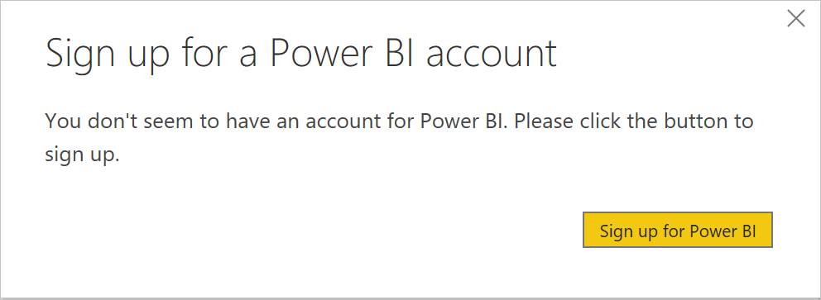
- Select Sign up for Power BI and follow the prompts to complete the sign up

Task 2: Prepare Data
- Find out your organization URL
  - Navigate to Power Platform Admin Center at https://aka.ms/ppac.
  - In the left navigation page, select Environments, and then click on the target environment.
  - Right mouse click Environment URL on the Details panel, then select Copy link.
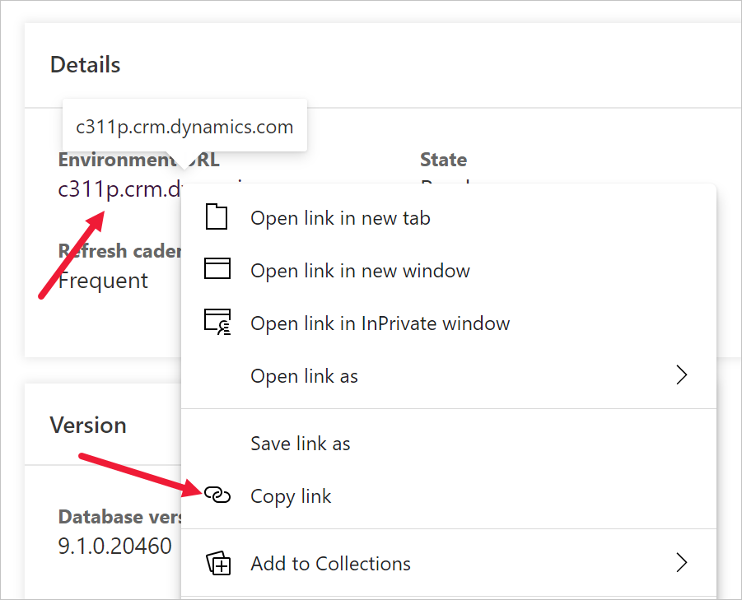
- Switch to Power BI desktop
- Select Get data | More...
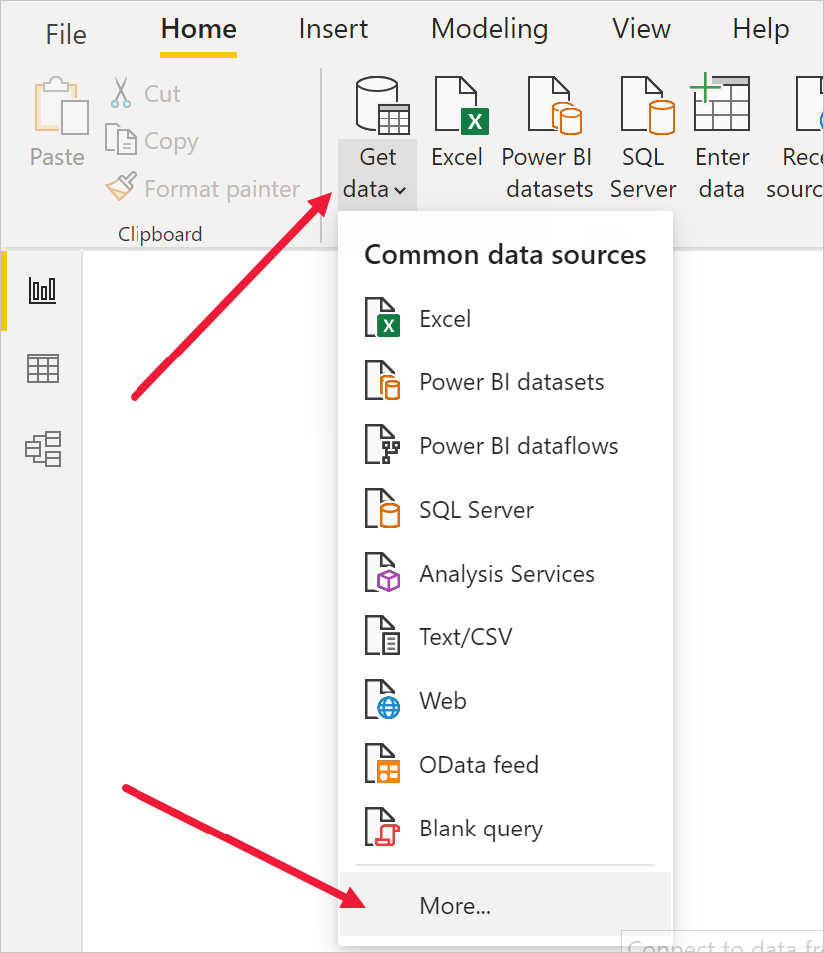
- Select Power Platform, then select Microsoft Dataverse, and press Connect.
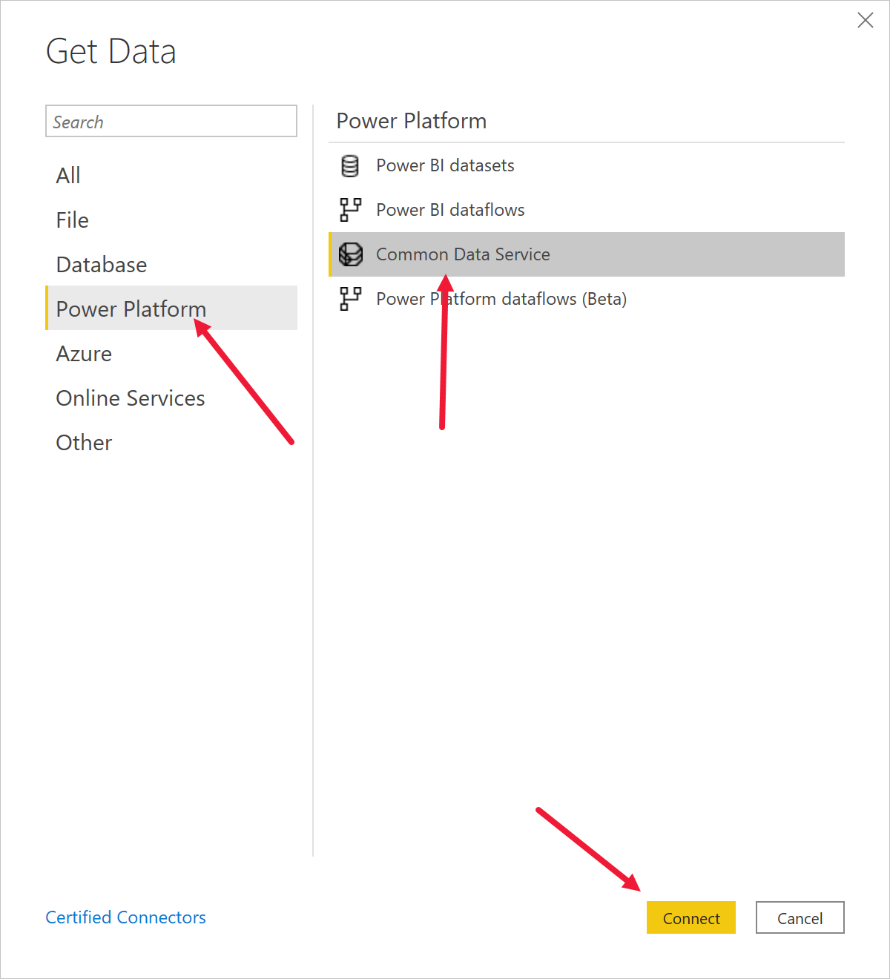
- Paste the environment URL you copied earlier, press OK.
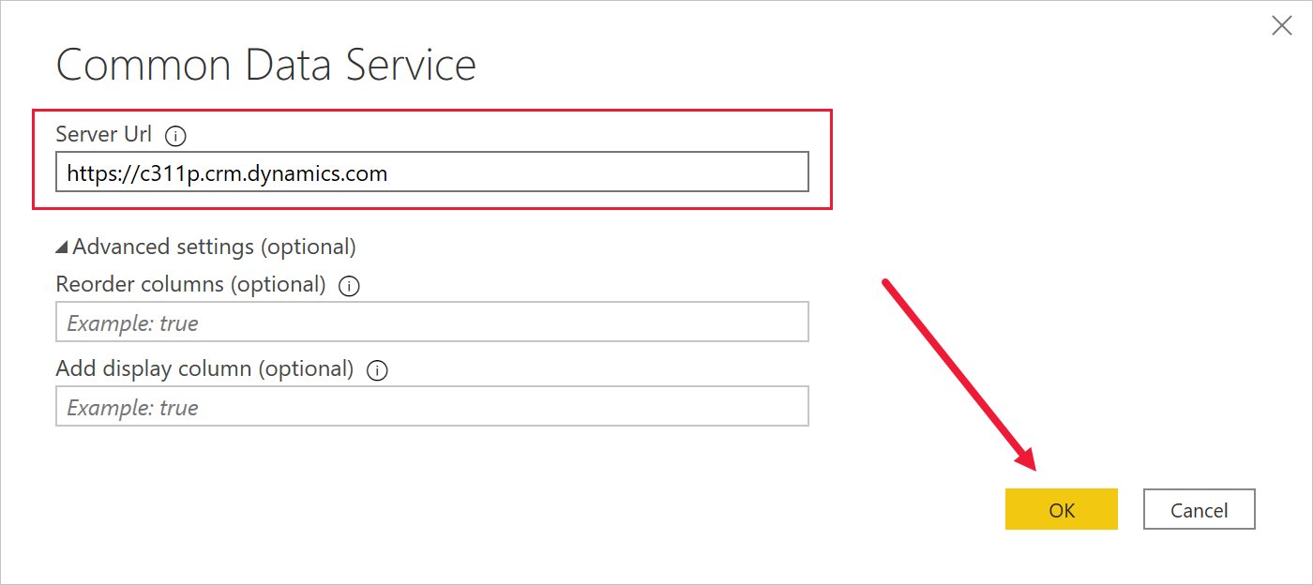
- The connection details dialog will open up. If you are not signed in, press Sign in and follow the prompts to sign in. Press Connect.
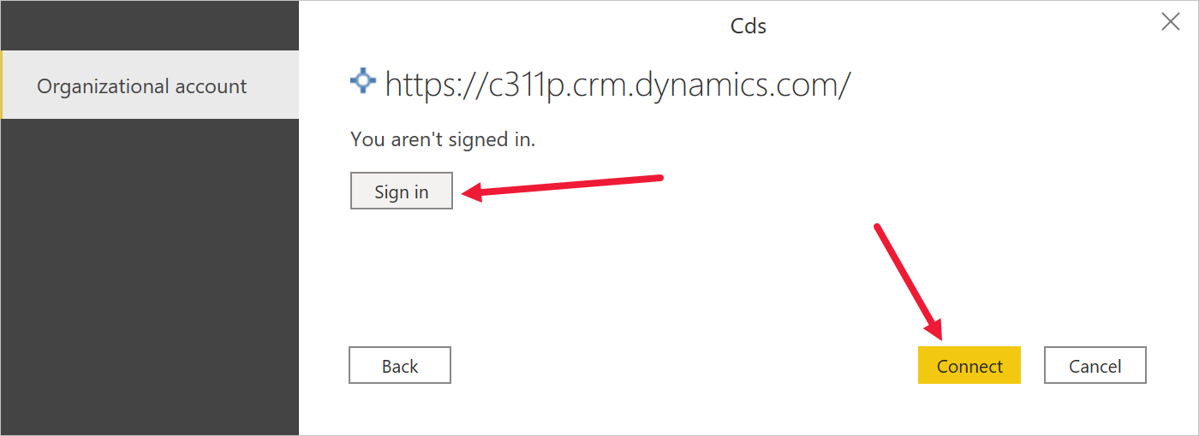
- Expand Tables node, select lh_Building, lh_Department, lh_ProblemReport Tables, press Load. Wait until the load is complete.
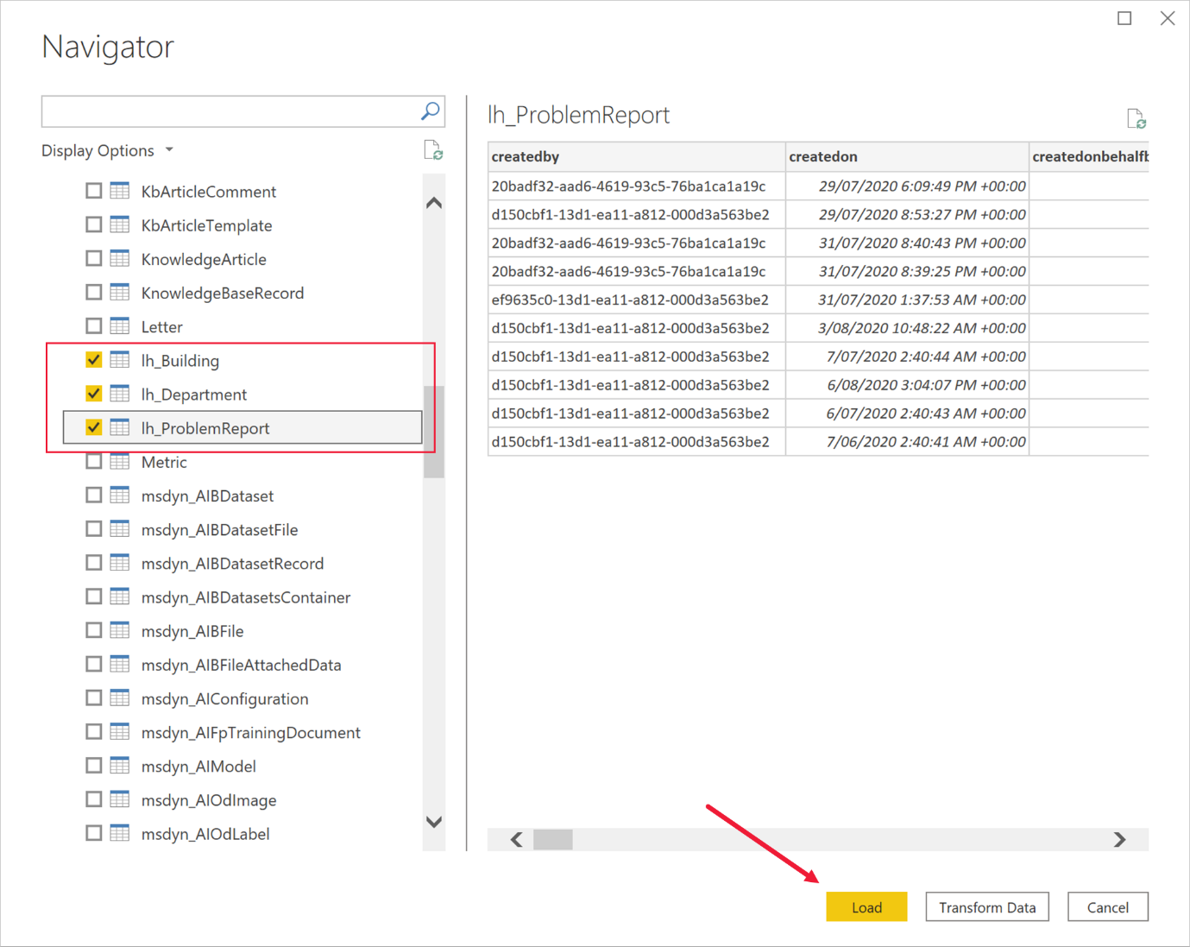
- Click Model icon on the left vertical toolbar.
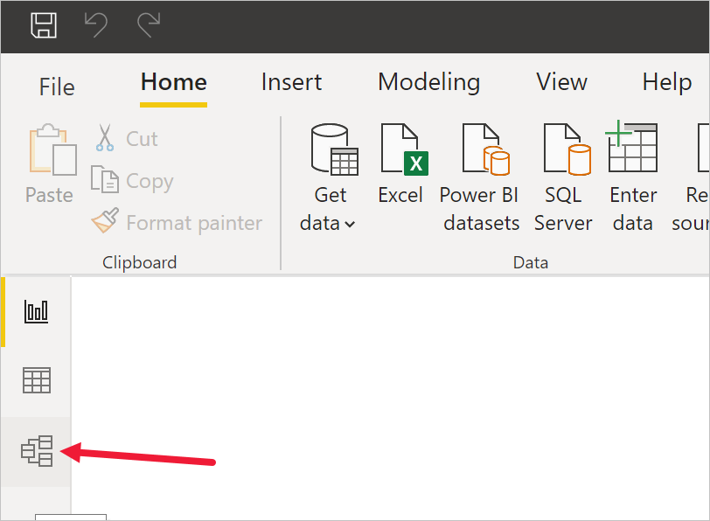
- Drag lh_buildingid column from lh_Building table and drop it to lh_building column in lh_ProblemReport table. That will create a relationship between two Tables that Power BI will be able to use to display related data.
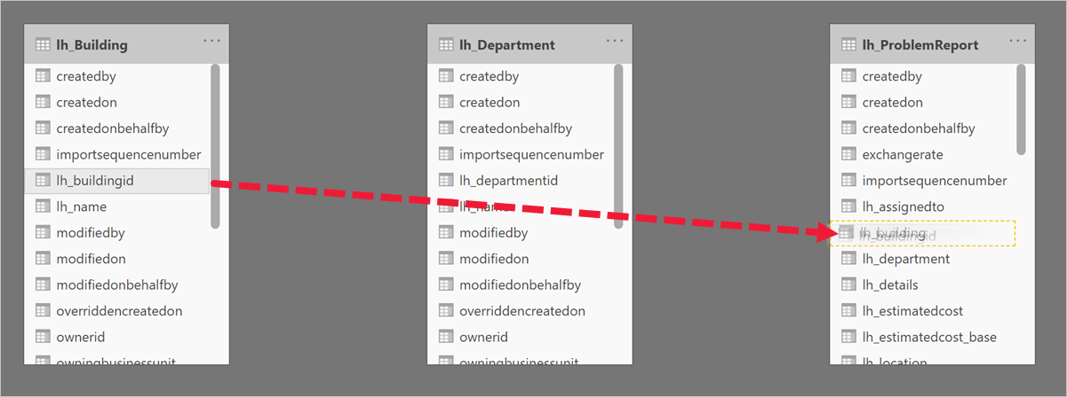
- Repeat the previous step to drag lh_departmentid column and drop it into lh_department column in lh_ProblemReport. Your diagram should look like this:
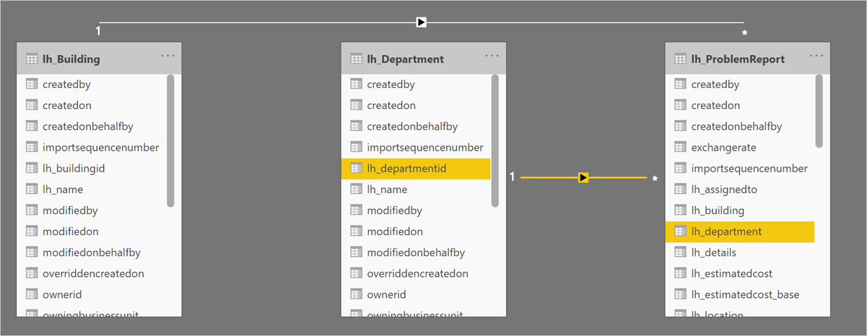
- Select Report icon on the left toolbar.
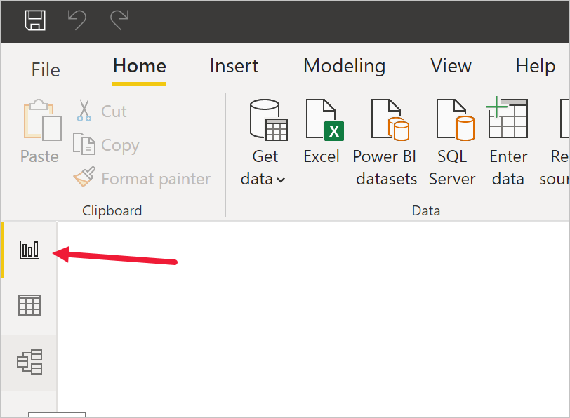
- Expand lh_ProblemReports node in the Columns panel.
- Click ... and select New Column.
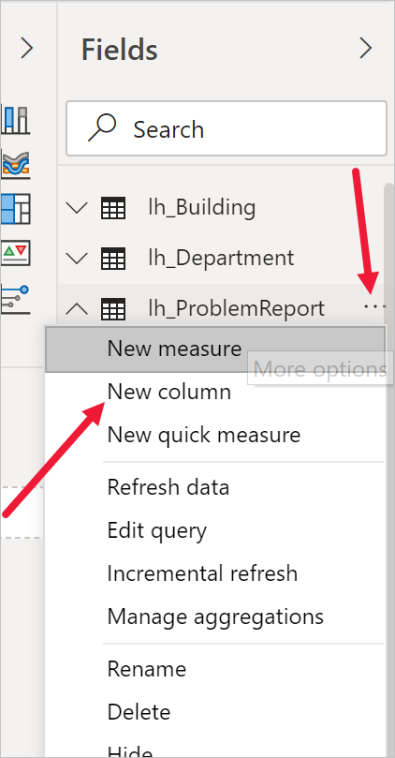
- Complete the formula as following
Building = RELATED(lh_Building[lh_name])
and press ENTER or click checkmark button. That will add a new column with the building name into the problem report data.
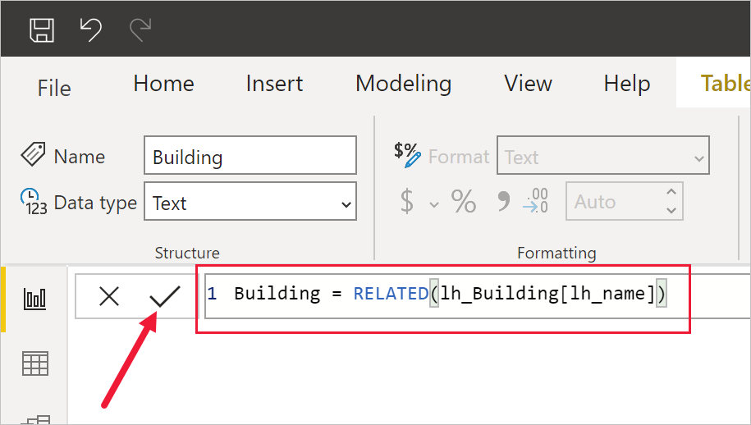
- Repeat two previous steps to add a column Department with the following formula
Department = RELATED(lh_Department[lh_name])
- Click ... next to the lh_problemreportid column and select Rename. Enter Problem Report as the column name.
- Click ... next to the statuscode_display column and select Rename. Enter Status as the column name.
- Save work in progress by pressing File | Save and entering a filename of your choice.
- Exercise 2: Create Power BI Report
Objective: In this exercise, you will create a Power BI report based on data from Microsoft Dataverse database.

Task 1: Create Chart and Time Visualizations
- Press pie chart icon in the Visualizations panel to insert the chart.
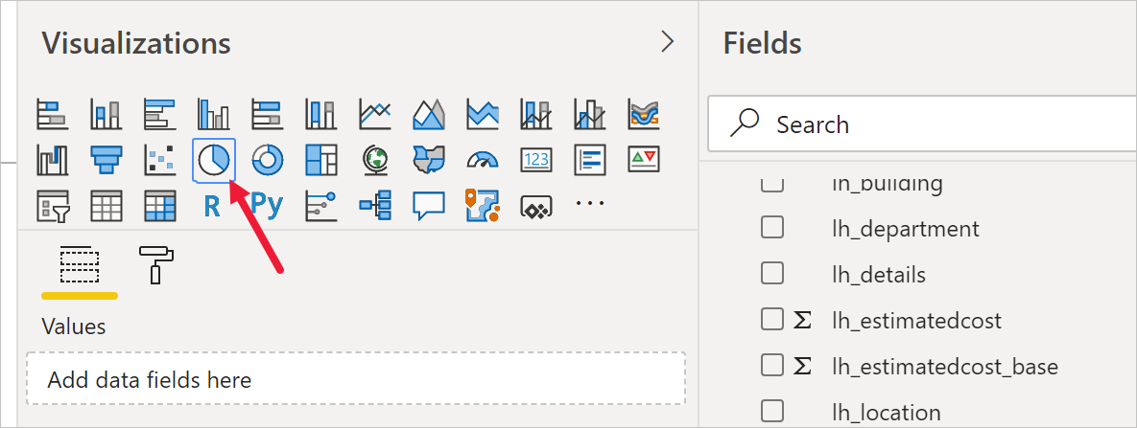
- Drag Building Column and drop it into Legend target box.
- Drag Problem Reports Column and drop it into Values target box.
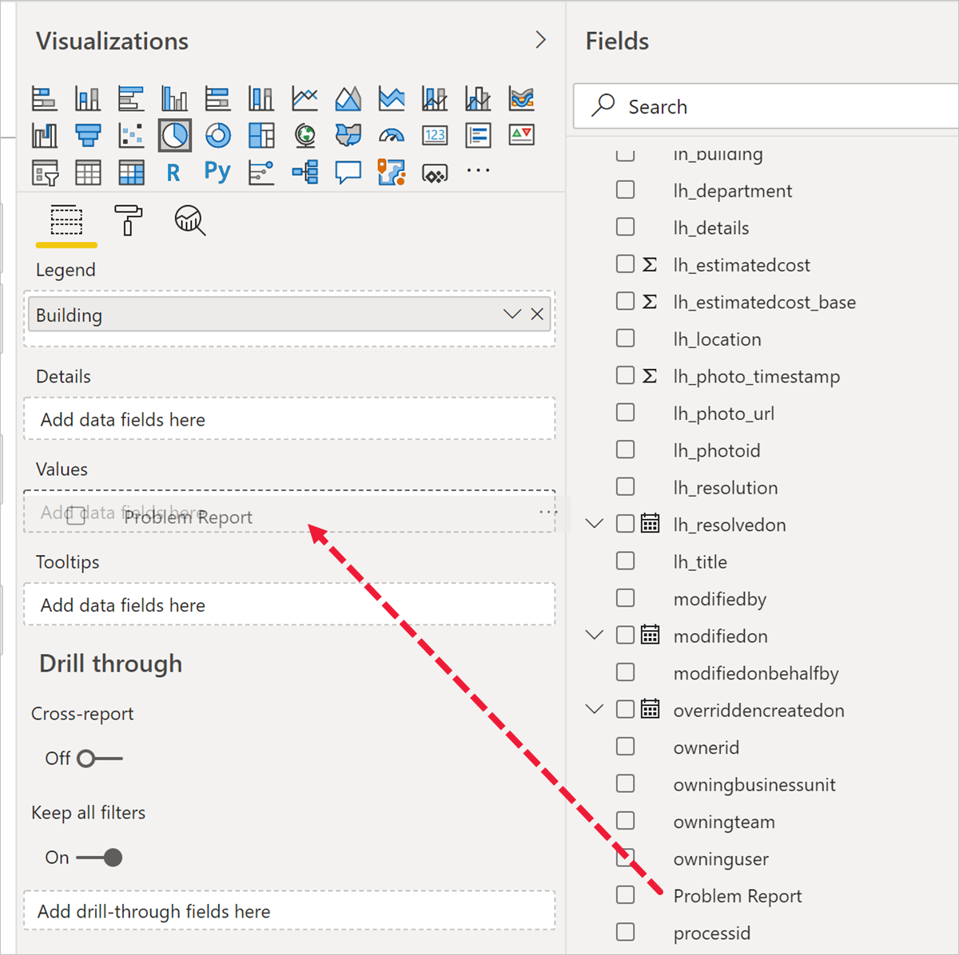
- Resize the pie chart using corner handles so that all chart components are visible. Your report should now look like this:
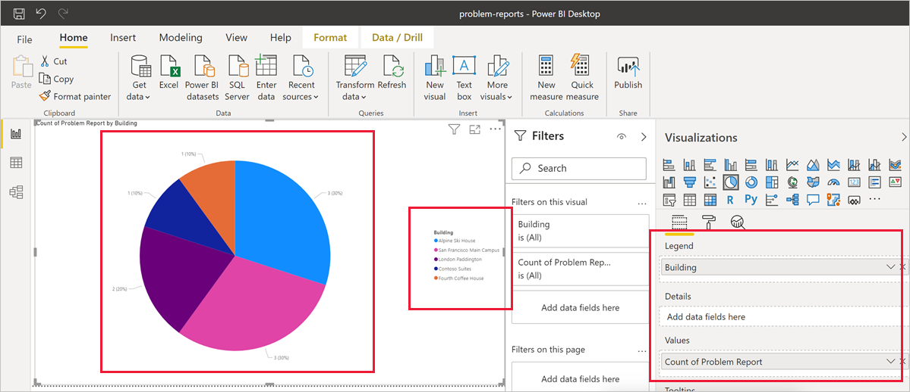
- Click New visual on the Power BI ribbon then select stacked column chart in Visualizations pane.
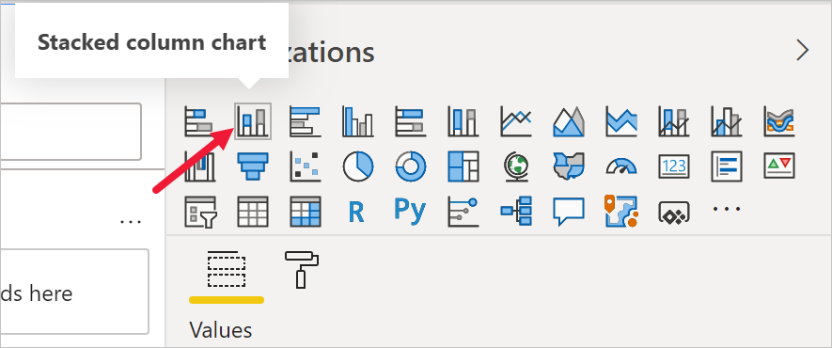
- Drag Problem Report Column and drop it into Values target box.
- Drag createdon Column and drop it into Axis target box.
- Click x next to Day and Quarter to leave only Year and Month totals.
[!TIP] Initial stacked column chart will only display the year level. To access monthly data breakdown you need to expand report into the monthly level. The easiest way to drill down is right-button click on the report and select Expand next level.
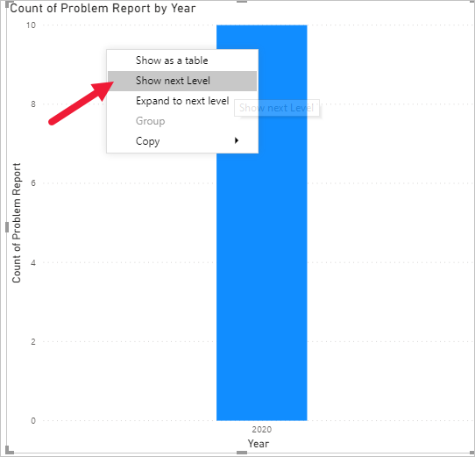
- Resize the chart as required using the corner handles.
- Test the report interactivity:
  - Select various building slices on the pie chart and observe changes on the time report.
  - Select various bars on the time column chart and observe changes on the pie report.
  - Drilldown to the month level using icons or Data/Drill | Expand next level ribbon command or drilldown toolbar
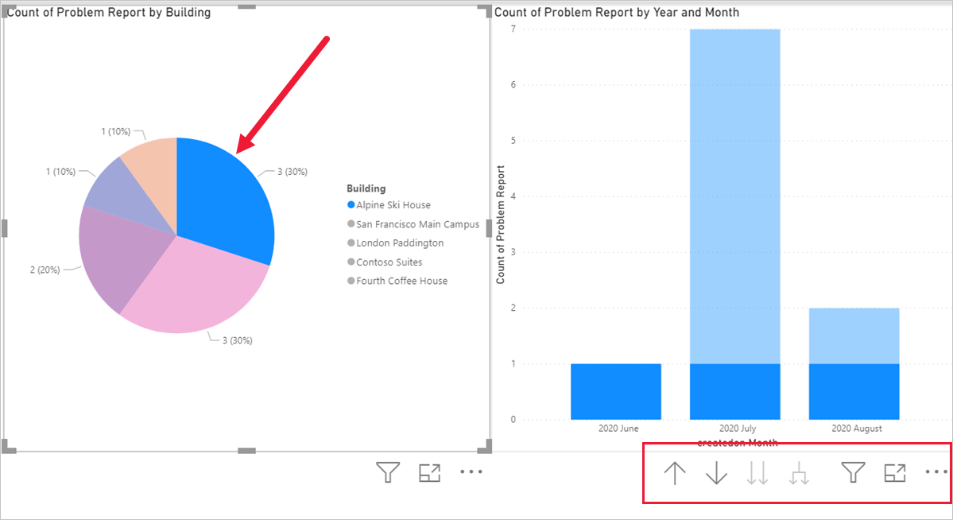
- Save work in progress by pressing File | Save.

Challenge
- Replace grouping by building with grouping by Status column
- Exercise 3: Create Power BI Dashboard

Task 1: Publish Power BI Report
- Press Publish button on the ribbon.
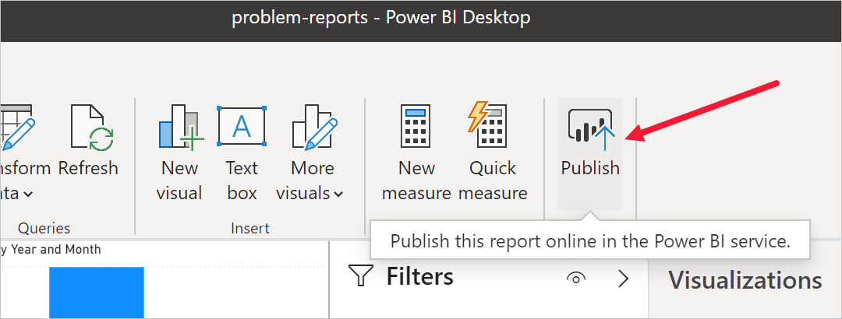
- Select My workspace as the destination, then press Select.
- Wait until publishing is complete and click Open <name of your report>.pbix in Power BI.
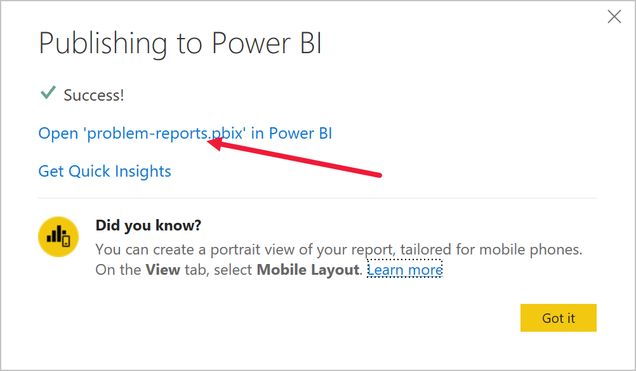
This will open the published report in the browser.

Task 2: Create Power BI Dashboard
- Expand My workspace.
- Select the report under Reports heading.
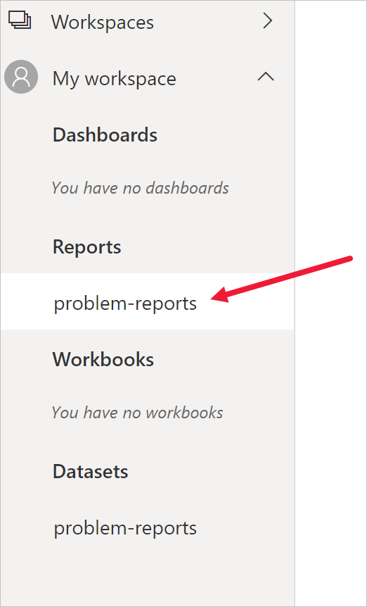
- Select Pin a live page on the menu. Depending on the layout you may need to press ... to show additional menu items.
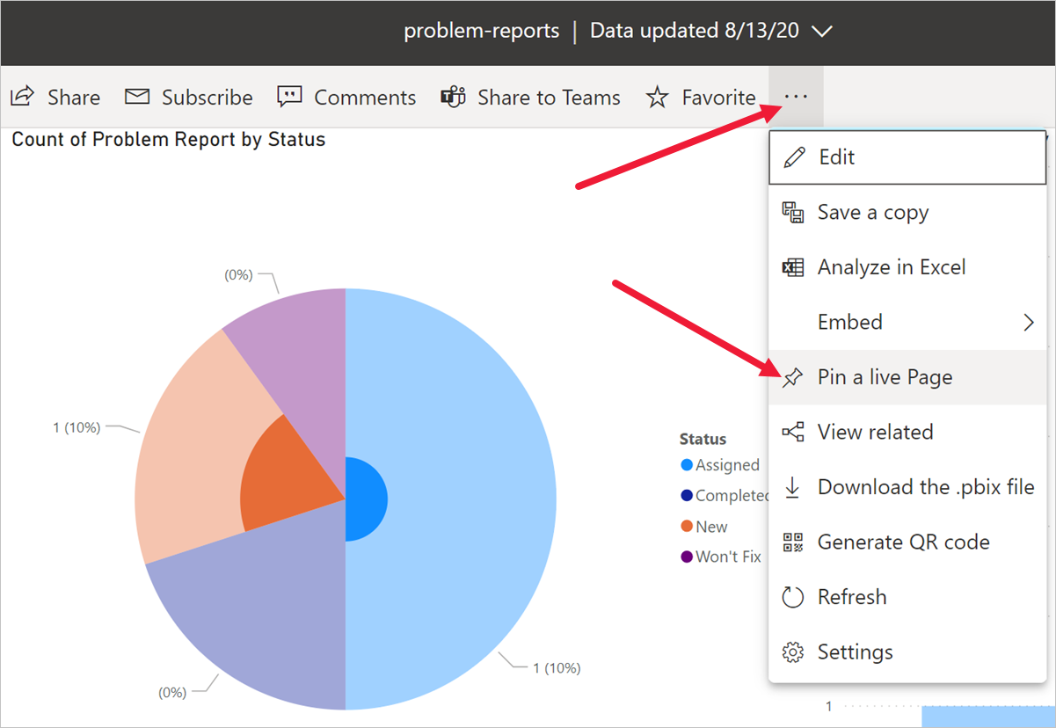
- Select New dashboard on Pin to dashboard prompt.
- Enter Problem Management as a Dashboard name, press Pin live.
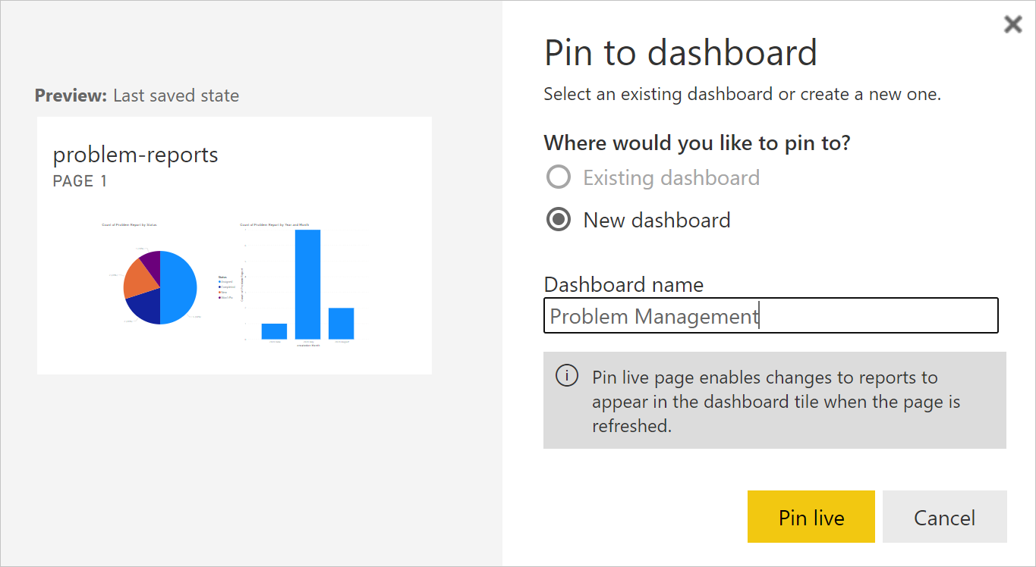
- Select My workspace node, select Problem Management dashboard.
- Test interactivity of the pie and bar charts displayed.

Task 3: Add Visualizations Using Natural Language
- Select Ask a question about your data on top of the dashboard
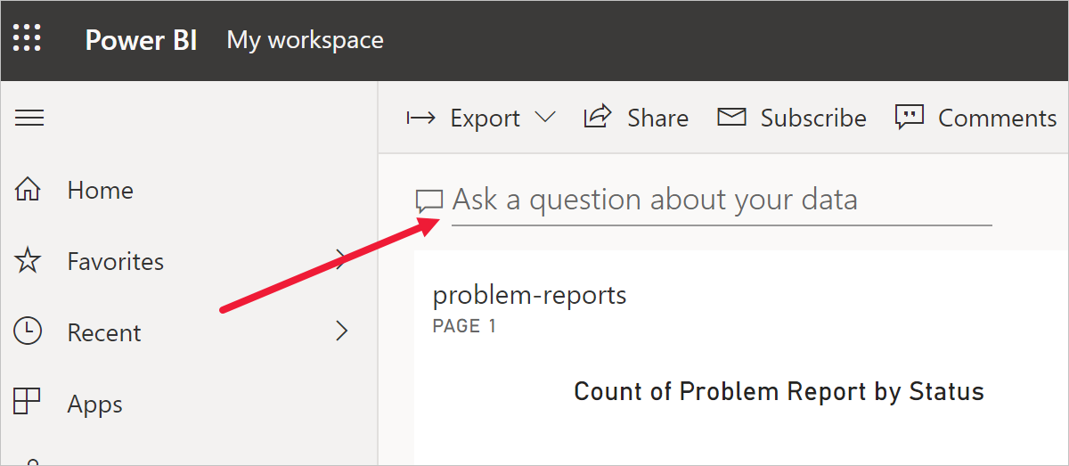
- Enter funnel count of problem reports by status in Q&A area. The funnel chart will be displayed.
- Select Pin visual.
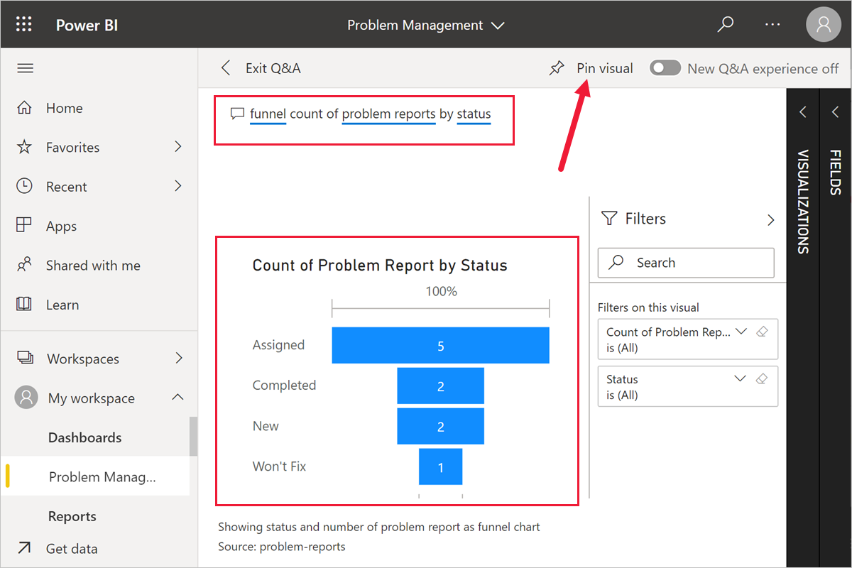
- Select Existing dashboard, select Problem Management dashboard, press Pin.
- Test the behaviour by clicking on the chart to drilldown to Q&A.

Task 4: Build Mobile Phone View
- Select the Problem Management dashboard from Dashboards area.
- Depending on the UI version select either ... | Mobile View or Web View | Phone View.
- Rearrange tiles as desired.
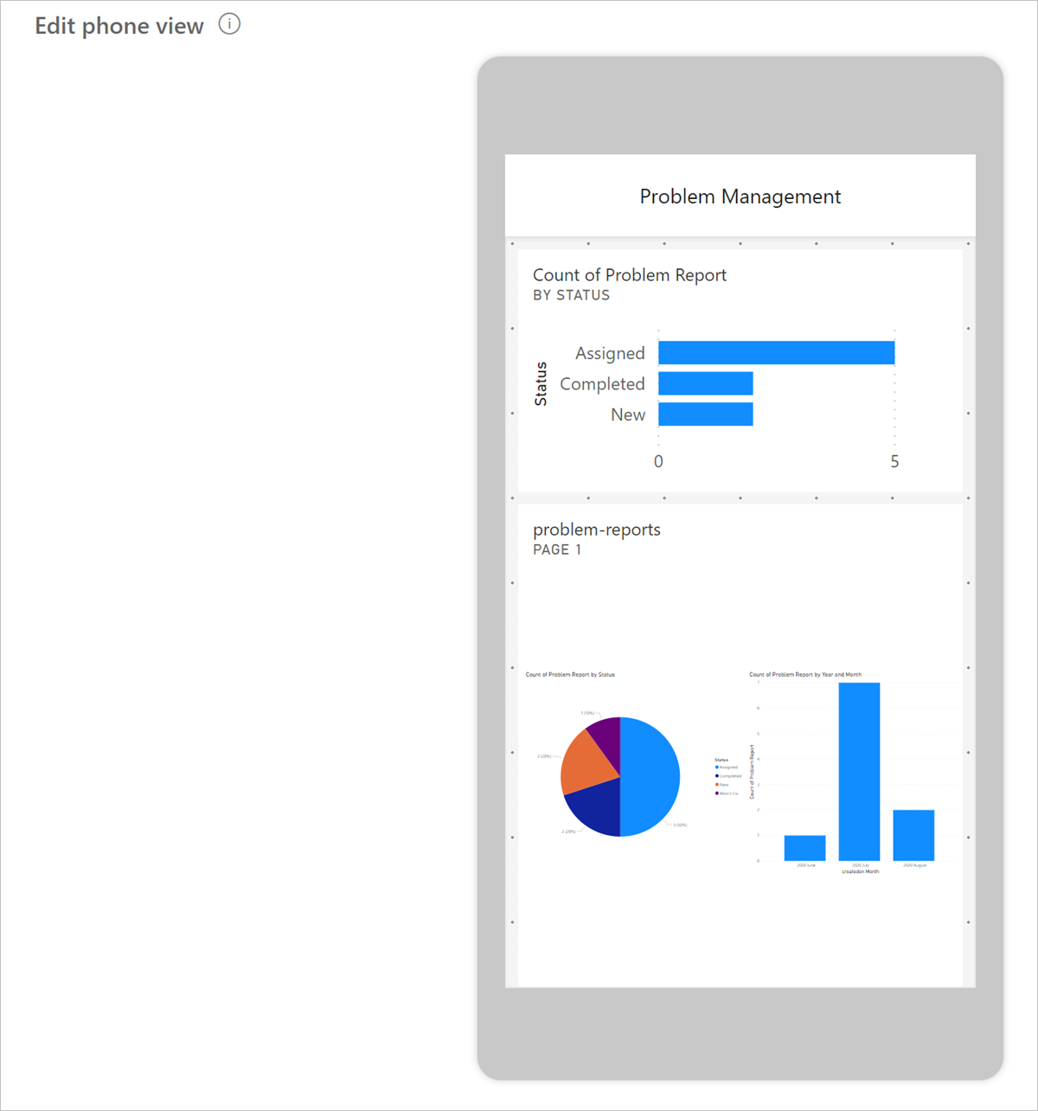
- Select your report under My Workspace | Reports
- Select ... | Generate QR Code.
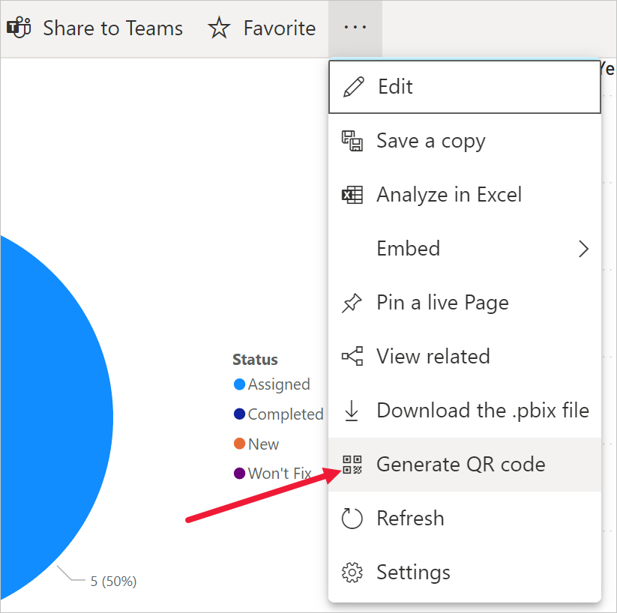
- If you have a mobile device, scan the code using a QR scanner app available on both iOS and Android platforms.
[!NOTE] To access the dashboard and report you will have to sign in on the phone as the same user.
- Navigate and explore reports and dashboards on a mobile device.
- Exercise 4: Embed Power BI report in Microsoft Teams
In this exercise, you will add the Company 311 Power BI report in Microsoft Teams as a way for management and staff to be able to view the reports from directly within Teams.

Task 1: Setup Company 311 Team
In this task you will setup a Microsoft Teams team for the Lamna Healthcare Company, if you have not done so previously.
- Navigate to Microsoft Teams and sign in with the credentials you have been using previously.
- Select Use the web app instead on the welcome screen.
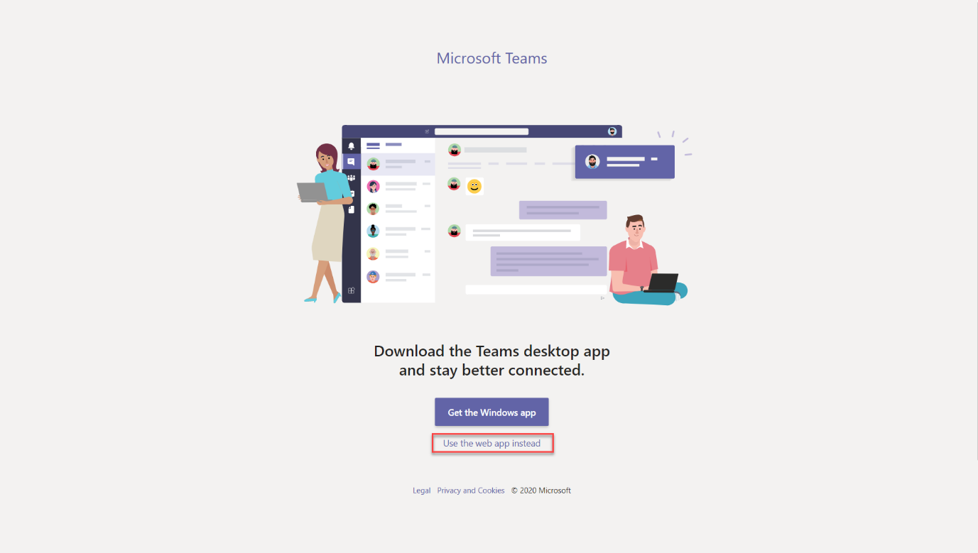
- When the Microsoft Teams window opens, dismiss the welcome messages.
- On the bottom left corner, choose Join or create a team.
- Select Create a team.
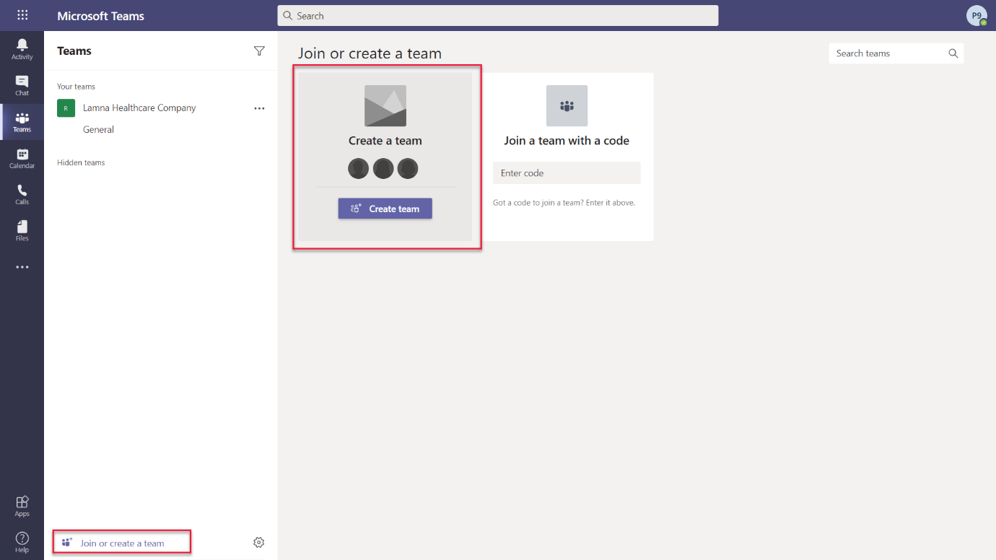
- Press Build a team from scratch.
- Select Public.
- For the Team name choose Company 311 and select Create.
- Select Skip adding members to Company 311.

Task 2: Embed Power BI report to Teams
- Navigate to Microsoft Teams
- Select the General channel of the Company 311 team.
- On the top of the page, press the + symbol to add a new tab.
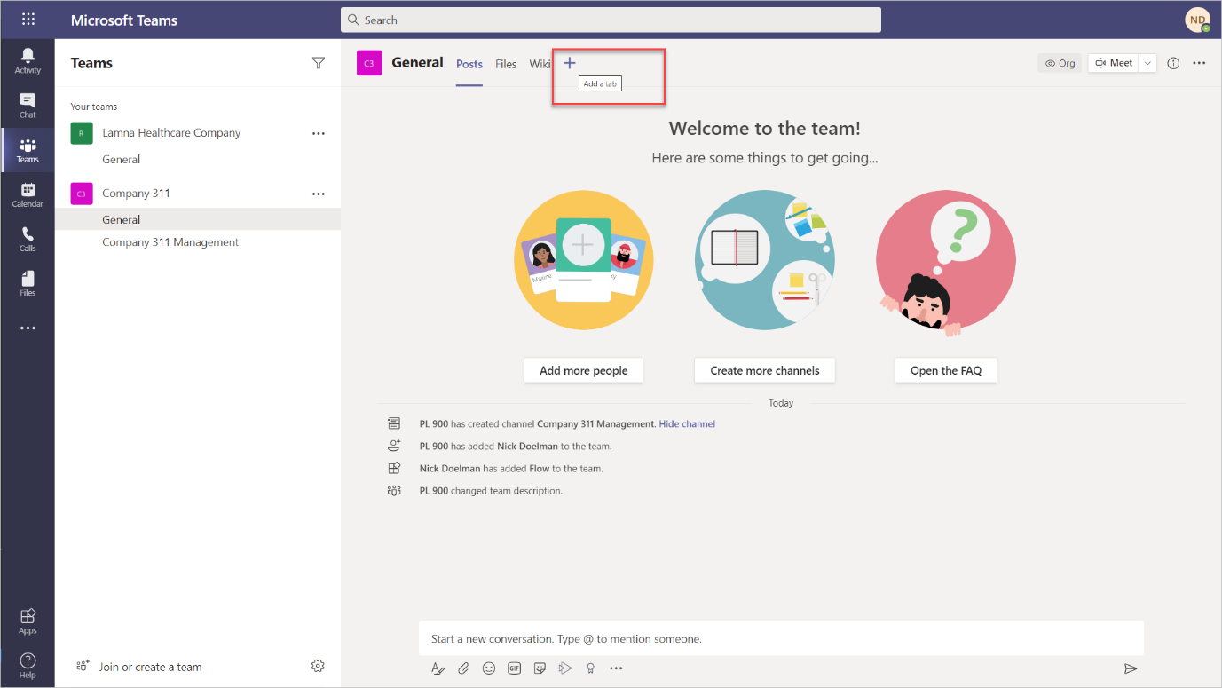
- Search for power and select Power BI from the results.
- Expand My workspace and select the report you created earlier in this lab.
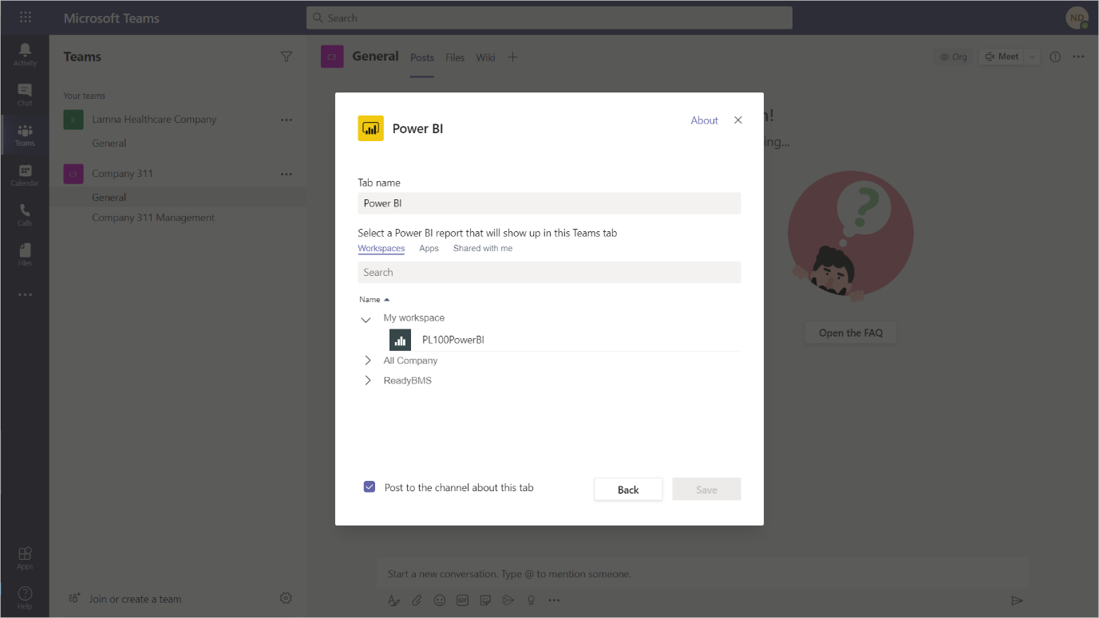
- Click Save You should now see your Power BI report in a tab in Microsoft Teams
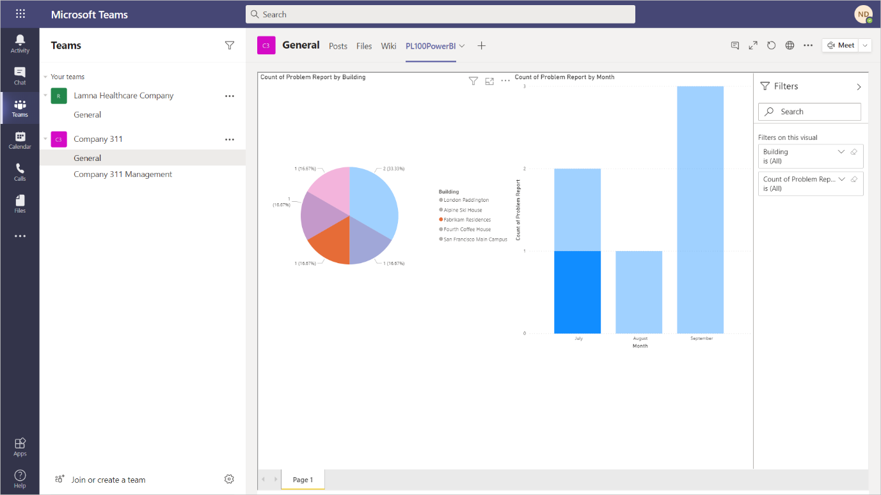
- Challenges
- Dashboards and reports to include drilldown to individual reports with photos
- Report and analyze problem patterns and trends
- Problem resolution status visualization as a funnel
- Addendum
- Exercise 5: Import sample data
In this exercise you will import sample data into Power BI service. That allows you to complete the lab exercises even if do not have required permissions to install desktop applications, or experience difficulties in configuring Power BI Desktop and connecting it to the data. After completion of this exercise you can resume the lab on Exercise 2 and use Power BI service (https://app.powerbi.com) instead of Power BI Desktop.
- Download problem-reports-data.pbix and save on your computer.
- Navigate to https://app.powerbi.com/.
- Click My Workspace.
- Expand +New and select Upload a file.
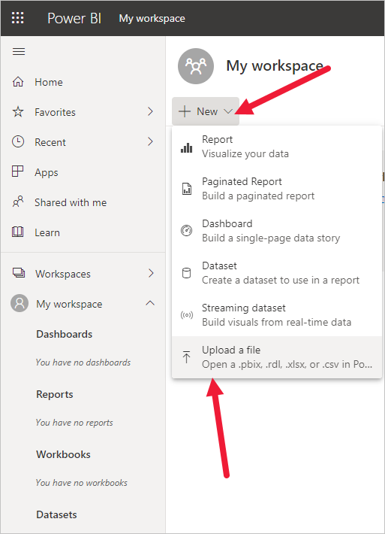
- Select Local File.
- Locate and select problem-report-data.pbix file you've downloaded earlier.
- Once data load is complete, select problem-reports-data report.
- Click ... then select Edit.
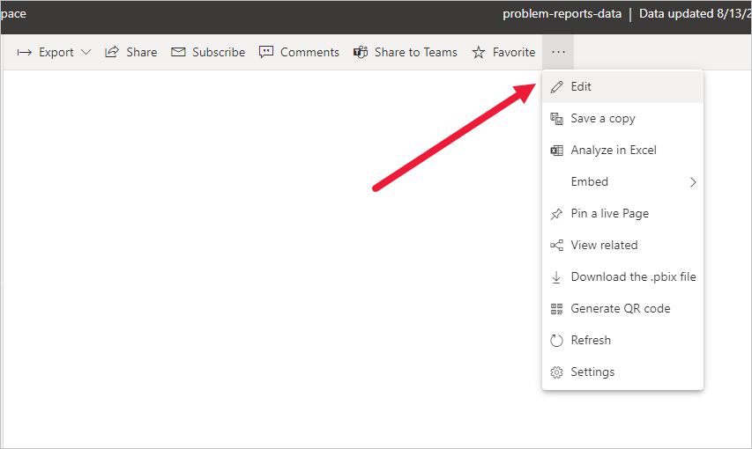
- Continue on Exercise 2.

